**NOTRE DAME UNIVERSITY - LOUAIZE**

**Faculty of Engineering**

**ECCE Department**

**EEN444**

Communication Systems Lab

**Instructor:**

***Dr. Nisrine El-Turkey***

**Final Report**

**Presented by:**

Mohammad Diab

***Remote monitoring of a generator***

**Abstract**

The main purpose of this project is to control the motor using a specific schedule from a mobile APP. It contains the following sensors and components:

* Temperature Sensor with a thermometer to display the internal temperature of the motor.
* Oil Level Sensor to display the oil level on a LED bar
* A grove touch sensor to check the availability of motion in front of the door
* Grove Light sensor to check if the motor exposed to light.
* Buzzer
* In case of emergencies like High temperature, Low Oil Level, or both cases a warning messages will pop up, so we can turn off the motor using force off button.

**Schematic capture:**

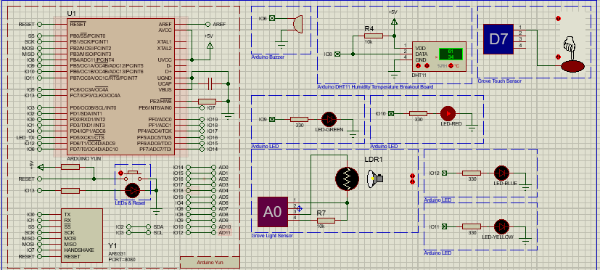

**IoT Control Panels:**

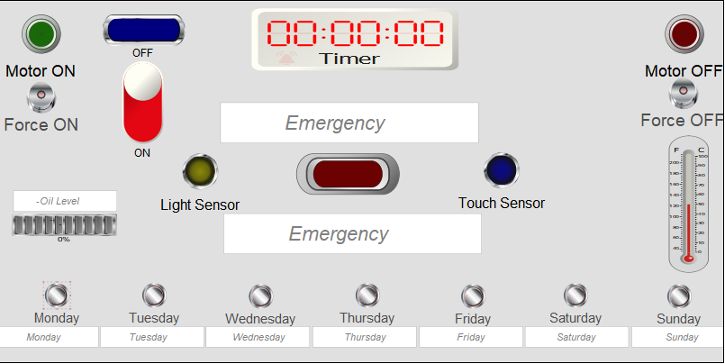

First of all, we can turn on the motor using the force on button or the weekdays buttons (In case the main switch is on, otherwise the buttons won’t work). Also, we have the force off button in case we have any error so we can force the motor to turn off. Moreover, if the main switch is on so the system of sensors will be on regarding if the motor is on or off. Then when we press any weekday button a period of 16 hours will be displayed below it and the alarm will go on. In case of any emergencies the Blue Led will turn on. In addition, there is a thermometer to display the temperature and a Led bar to display the oil level. Moreover, the light sensor will go on if the motor is being affected to light , also the touch sensor if there is any motion detected infront of the door. Finally, even if the motor is working properly and there is no emergency case , in case we pressed two weekday buttons at the same time then the system of sensors and the motor will both go off with a message saying error / system shutdown .

**Flowchart & Simulations:**

**Cases:**

**Case 1: Turn on and off the motor**

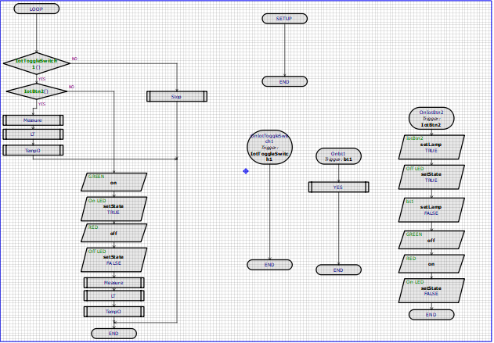

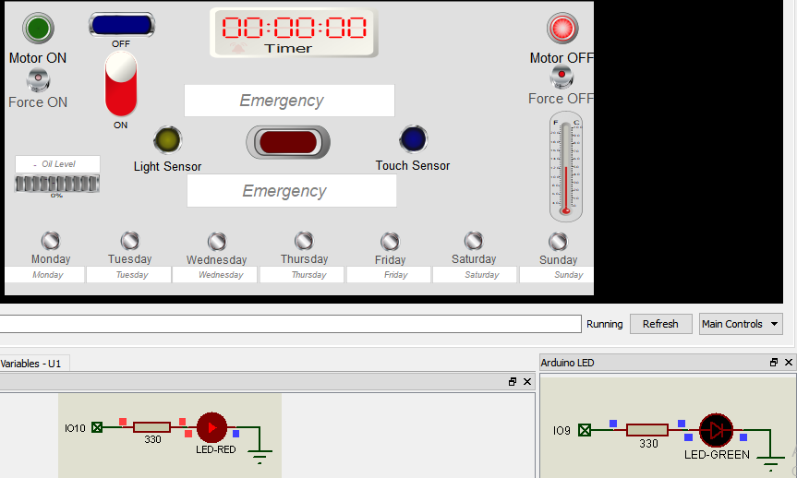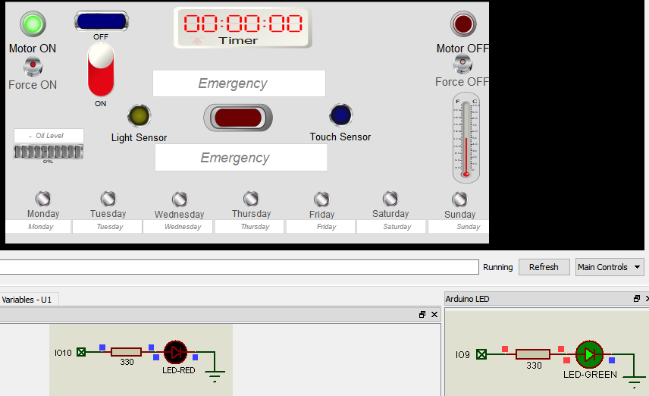

**Case 2: Switch On , and two weekday buttons are pressed (Monday & Wednesday)**

**Note: There is one more sheet containing the other buttons.**

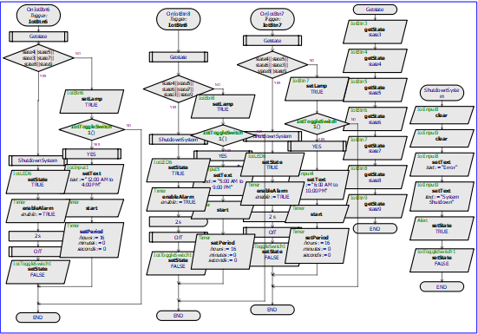

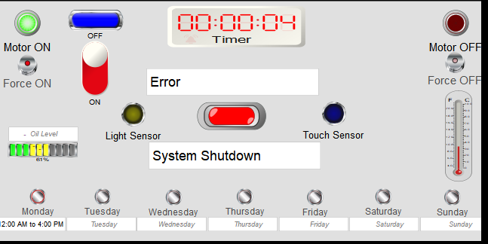

* Blue led, Monday button, motor, and the timer all will go off. (not clear in the screenshot).

**Case 3: If we press any weekday button while the main switch is on, both timer and motor will go on.**

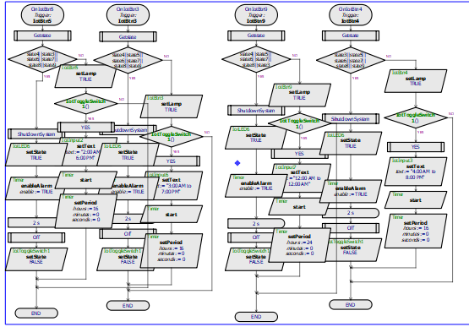

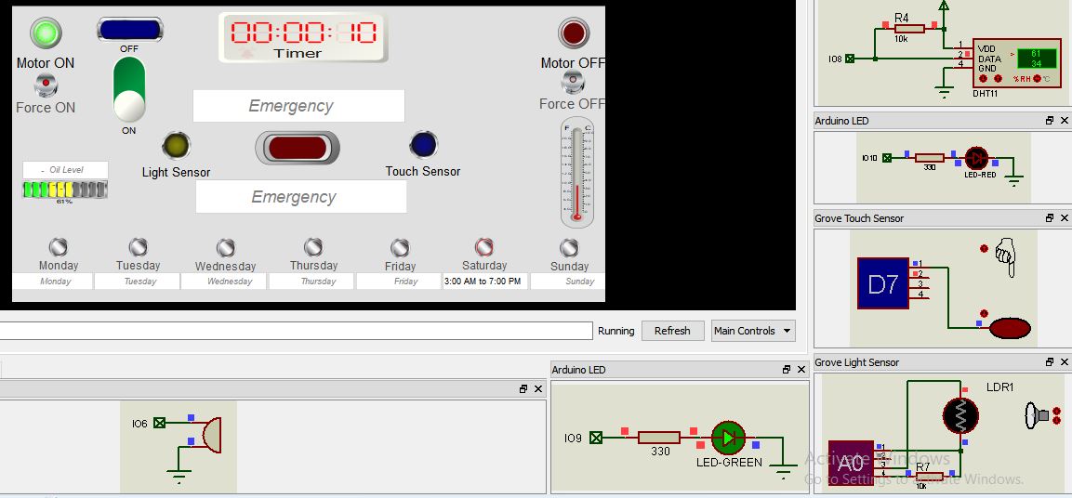

* Saturday button is pressed and the timer is on with no errors detected by the system.

**Case4: Low oil level case, high temperature case, or both cases are detected. ( I used a macro called measure in order to measure the inputs from the hardware part).**

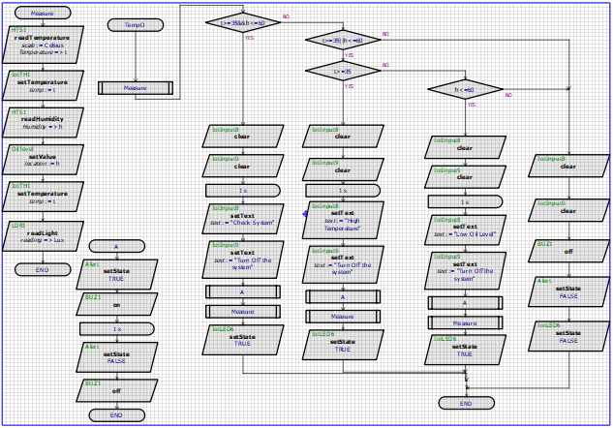

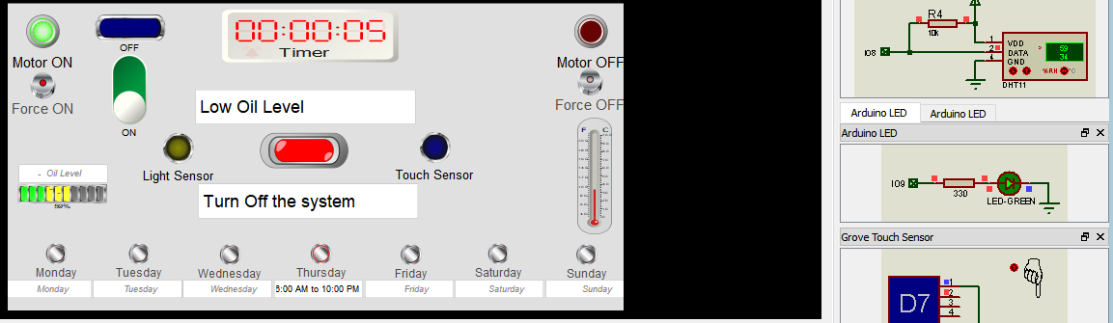

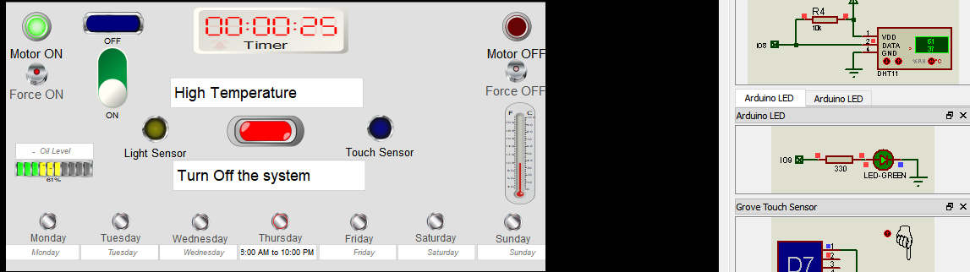

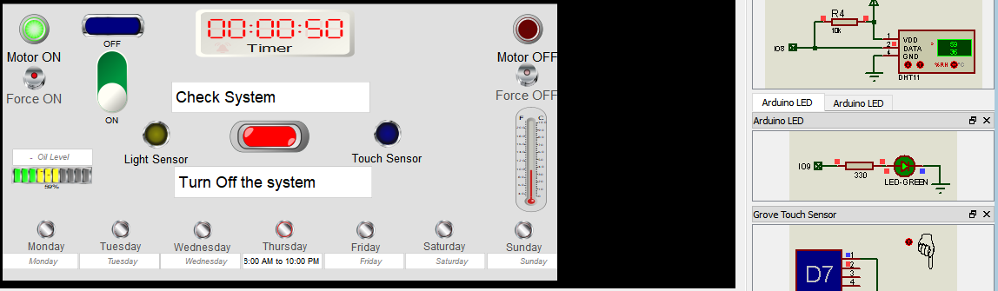

* The thermometer is displaying the temperature while the led bar is displaying the oil level
* The Blue and Red leds are both alerts that detect any emergency situation.
* Buzzer is on in all these situations.

**Case 5: Touch sensor is on, Light sensor is on, or both sensors are on.**

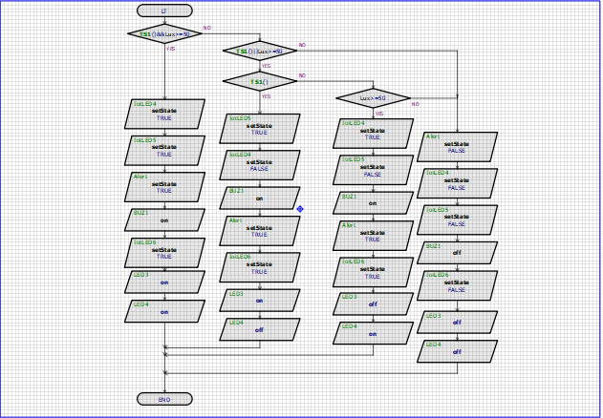

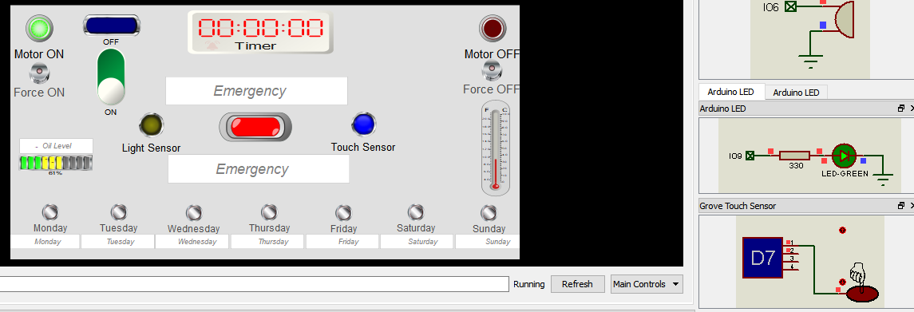

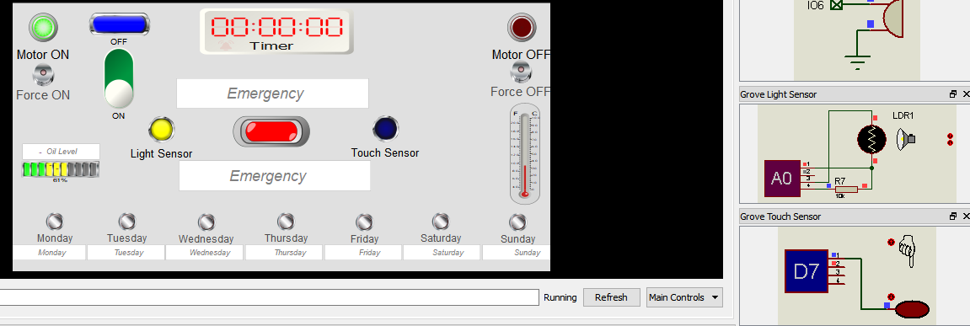

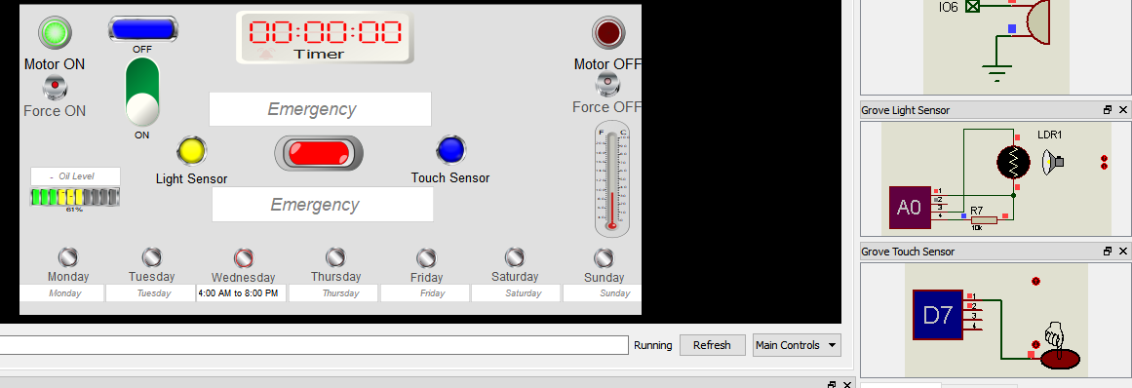

* There is no meaning for writing emergency message in these cases
* We can now see that the blue led is on.
* Even if the motor is off the system of sensors can still work independently.

**Case 6: Both 4 and 5 cases.**

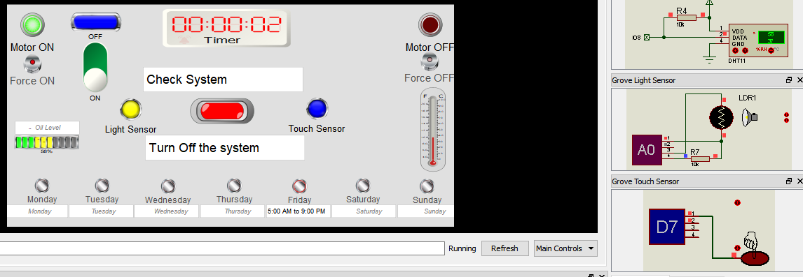

* Buzzer is on.
* Alert leds are on.
* Light and touch sensors are on
* An emergency message popped up saying check system.
* Temperature is high and the oil level is low as displayed (thermometer/ led bar).
* Timer is on as sechduled for Friday (5:00 AM to 9:00 PM).

Flowchart: ( sheet: Yes/No).

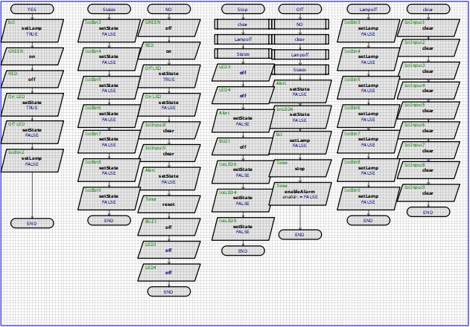

* This flowchart is used to take control over the leds and display texts during the process.